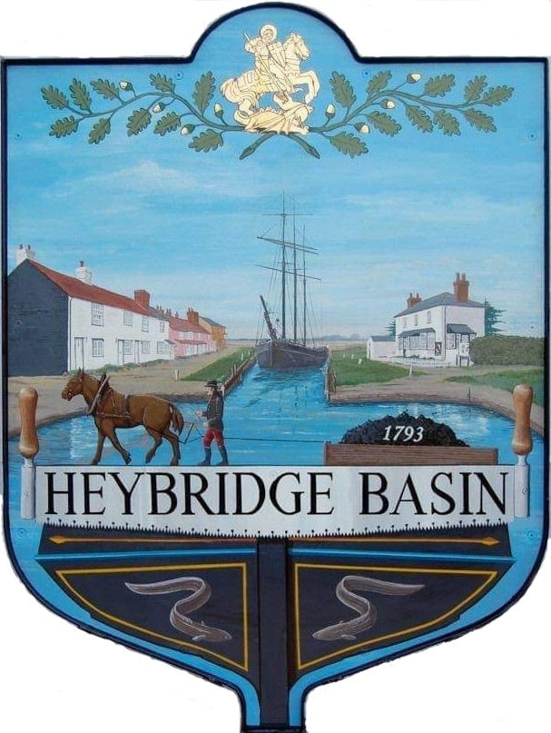

HEYBRIDGE BASIN PARISH COUNCIL

Minutes of the Full Council meeting of Heybridge Basin Parish Council held on Tuesday 17th December 2024 at 06:30pm, at St George’s Community Room.

PRESENT

In the Chair: M. Hodges (Chair) Absent: 0

Councillors: R. Bryson (Vice Chair) Apologies: 2
J. Sjollema
C. Edmond District Cllrs: 2
C. Swann
Public: 0

Officers: G. Lake – Clerk

It was noted that this meeting was being recorded by the Clerk.

24/137 Chair’s Welcome.
The Chair opened the meeting and provided updates on recent activities:
- Attended the local transport meeting, where it was confirmed that the bus service in Heybridge Basin will not be reviewed for another 3.5 years.
- Attended the Parish and Town Council Forum, which included extensive discussions on Neighbourhood Plans. The option of a design code was highlighted but requires further research.
- Noted that Heybridge Parish Council is progressing with its Neighbourhood Plan, with the next steps involving a housing needs survey.

24/138 To note apologies for absence.
Cllrs Howat and Hobden.

24/139 To receive Declarations of Interest in accordance with the Council’s Code of Conduct and with section 106 of the Local Government Finance Act 1992.
Cllr Edmond – Non-Pecuniary – Essex Waterways

24/140 To sign as a correct record the minutes of the full council meeting held on 19th November 2024.
The Minutes as previously circulated were agreed and signed as a correct record.

24/141 To receive a report from:
- District Councillors – Cllr Spenceley gave a verbal report regarding the recently approved National Planning Policy Framework as well as the news surrounding the devolution and local government reorganisation.
- County Councillor – No report was received from Cllr Durham

24/142 Finance.
- To approve
- Payment requests for November/December 2024 were approved.
- Receipts for November/December 2024 were approved.
To consider finalising the budget and setting the precept for 2025/26 and agree any action to be taken. The Council agreed the proposed Precept of £30,500 for 2025/2026 which is a 3.18% decrease from the current financial year 2024/2025.

24/143 Public Forum
There were no members of public.

24/144 Planning
- To consider any planning applications received after the publication of the agenda and to agree the action to be taken.

24/00946/WTPO – Land adjacent Myrtle Cottage, Lock Hill – (TPO 02/24) G1 (Group of 2 Horse Chestnut) – Crown lift to provide a clearance of 3m.
It was resolved to object to this planning application on the grounds that the existing clearance is already 3 meters, making the proposed work unnecessary. Cllr Edmond abstained from the vote due to his declared non-pecuniary interest.

24/145 Daisy Meadow Car Park (DMCP)
  - To discuss the design and costs for the car park garden at the old toilet block and agree any action to be taken.
A discussion regarding costs was held; however, due to the lack of clarity, it was resolved that Cllr Bryson would collate the information and circulate it to all members ahead of the next meeting.

24/146 VE Day 2025
  - To receive an update from the Working Group and agree any action to be taken.
The Clerk previously circulated a report outlining tasks to be completed and addressing questions related to the event. Tasks were delegated to members of the Council and the Clerk. The Clerk will update the notes accordingly and recirculate them.

24/147 Clerk’s Report
- Basketball Hoop – The Clerk confirmed that the basketball hoop installation was underway. The concrete was currently setting, pole to be installed once ready. Once complete the Clerk will complete the funding form which needs to be completed and submitted to Tesco by 3rd January.
- Interim Audit - The interim audit is scheduled for February and the Clerk confirmed that preparations would be the focus after the Christmas period.

24/148 Correspondence
- To note correspondence received and agree any actions to be taken.
Correspondence was noted and responses were agreed.
It was resolved to donate £150.00 towards refreshments for the upcoming Warm Hubs.

There being no further business the meeting closed at 07:42pm
Provisional Date of the next Council Meeting Tuesday 14th January 2025

Clerk Contact details: clerk@heybridgebasinpc.org.uk
Website: www.heybridgebasin-pc.gov.uk

